**3D Printed Smart plant base (smart home)**

*S. Kaarthik Raja, R. Anerudh, V. Dhana Akarshan*

*Guide: Mr.M.Mohan*

*Department of CSE, Panimalar Engineering College ,Chennai*

**ABSTRACT:**

Whether it be for work or pleasure, travelling is always a whole lot of fun. It gives us new experience and opportunities to grow as a “**Human**”.But what about the growth of your house plant’s while your away. Or what if your in home and you forget to water it or overwater it. That’s going to be a bummer. I have the perfect solution for all these problem’s, why not make an automatic watering system?This Arduino based, uses a moisture sensor to measure the moisture level of the soil, the sensor is stuck into the soil and then flashes LEDs and provides an OLED display readout telling you whether you’re over or under watering your plant. The LED emits red light when you forget to water it and it waits for a while and if you don’t show up to water your plants, it automatically water it.This 3D printed ”**Automatic Smart Plant Pot”** looks simple on the outside, but inside there are electronics, pumps, and a water reservoir that work together to keep your plants healthy and happy.

**I. INTRODUCTION**

Since nowadays, in the age of advanced electronics and technology, the life of human being should be simpler and more convenient, there is a need for many automated systems that are capable of replacing or reducing human effort in their daily activities and jobs. Here we introduce one such system, named as automatic plant watering system, which is actually a model of controlling irrigationfacilities that uses sensor technology to sense soil moisture with a microcontroller in order to make a smart switching device to help millions of people 1 . Can we automatically water our home and garden plants without bothering our neighbors when we decide to go on vacation or somewhere else for a long period2? Since irregular watering leads to the mineral loss in the soil and may end up with rotting the plants, can we then somehow know if the soil really needs to be watered and if so, when exactly do we have to water the plants? Is it possible in any way from remote location to manage our plants to be watered 2? These are some questions that can be heard quite often and answer on all of them is encouraging and affi rmative, because advanced technology provides us very wide range of possibilities nowadays. Actually, there is a very simple and economical solution for all these questions and perplexities. In the form of unique intersection between biological engineering and electronics, the solution requires only a little bit knowledge of electronics as well as that knowledge related to botany and plant physiology

# II.Method & Material’s Used

Although there are some companies selling these systems made in various ways, there is a simple way in which one can build his/her own plant watering system in just a few hours, if all required materials are available along with basic required knowledge about electronics. For the purpose of building this system one will need to properly connect following:

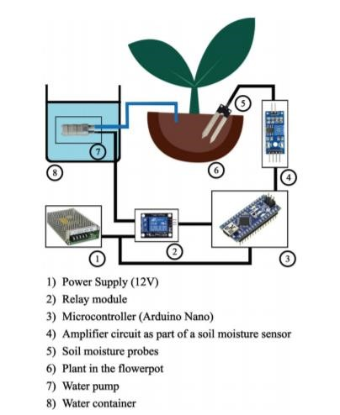

The figure above shows the connection of all above mentioned materials in the system. (Figure 1) In our experiment, we connected all required materials exactly as shown in Figure 1 above, in order to test whether our system will work properly or not. Also, the overall behavior and the appearance of our plant, that was subject of the experiment, were observed in the following 30 days.

# Working Principle

The main working principle behind this system is in connecting the soil moisture sensor, which was previously embedded into the plant, to the Arduino microcontroller, which is also connected to other electronic components listed above as shown in Figure 1.

Measurement of soil moisture is done by the sensor which forwards the information and parameters regarding the soil moisture to the microcontroller, which controls the pump. If the level of soil moisture drops below a certain value, the microcontroller sends the signal to the relay module which then runs a pump and certain amount of water is delivered to the plant. Once the enough water is delivered, the pump stops doing its work. Power supply has a task to power the complete system and the recommended voltage should respect the input supply range for the microcontroller, that is, from 7V to 12V. Relay module is a simple circuit consisting of a single transistor, several resistors, diodes and a relay and it is controlled digitally by microcontroller. Since the complete system should be embedded in a small box, Arduino Nano is a perfect microcontroller for this purpose because of its dimensions and its work performance. Soil moisture module is consisting of the two parts: amplifi er circuit and probes. This module has digital and analog outputs, where digital output is set to logical 1 when the threshold is activated. The threshold is set by potentiometer. Analog output gives the real time information regarding the moisture in the plant and this output is used in the system. Water pump is connected to the relay module and it only works when the relay module gets a command from the microcontroller, whose working principle is described via fl ow chart diagram in Figure 2 below as well as by the following pseudocode:

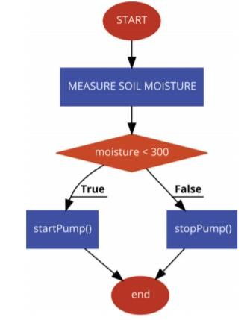

# RESULTS AND DISCUSSION

1. **System Architecture**

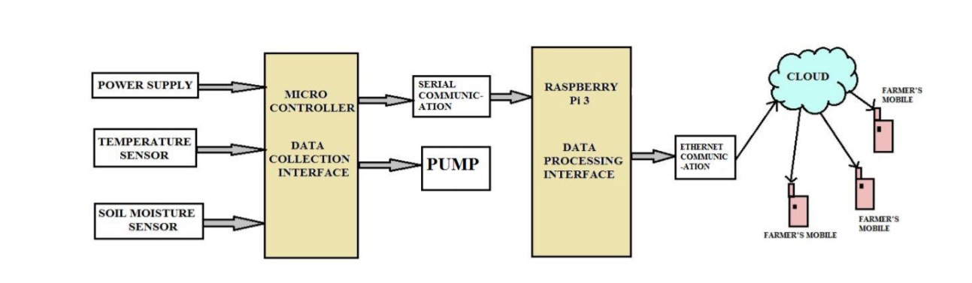

**B. Data Flow Diagram**

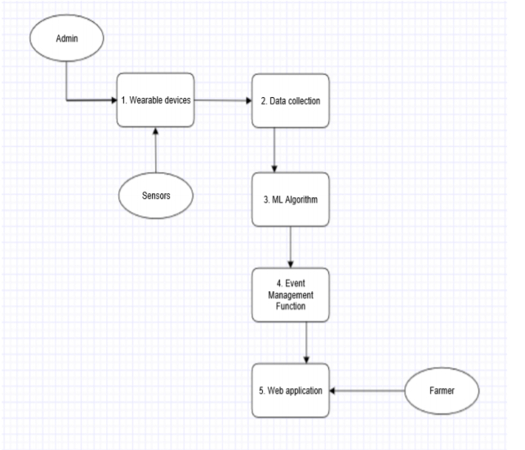

1. **Use Case Diagram**

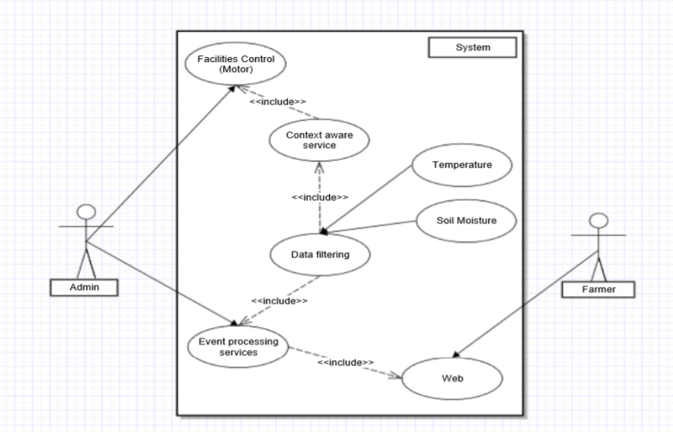

**D. Sequence Diagram**

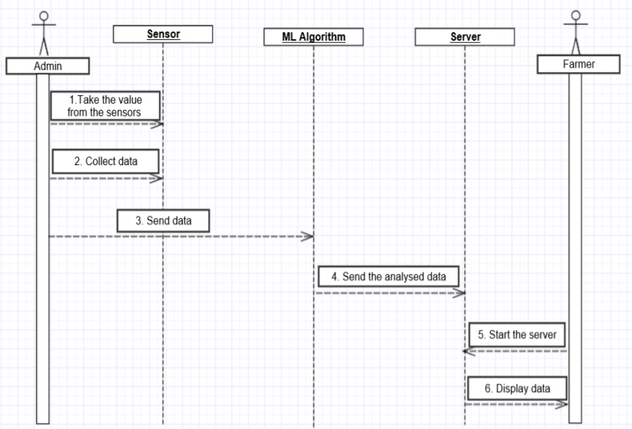

1. **Context Diagram**

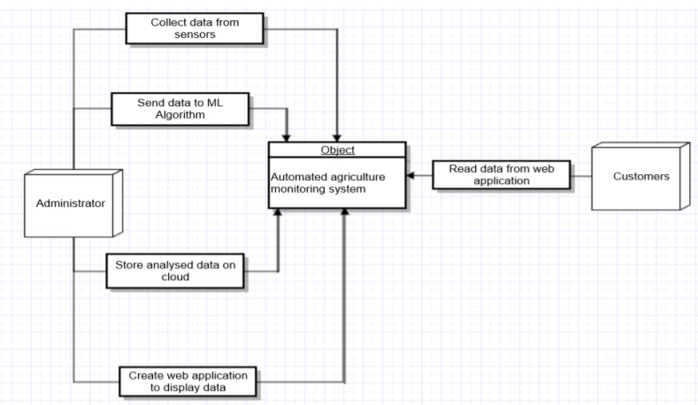

1. **Flow Diagram**

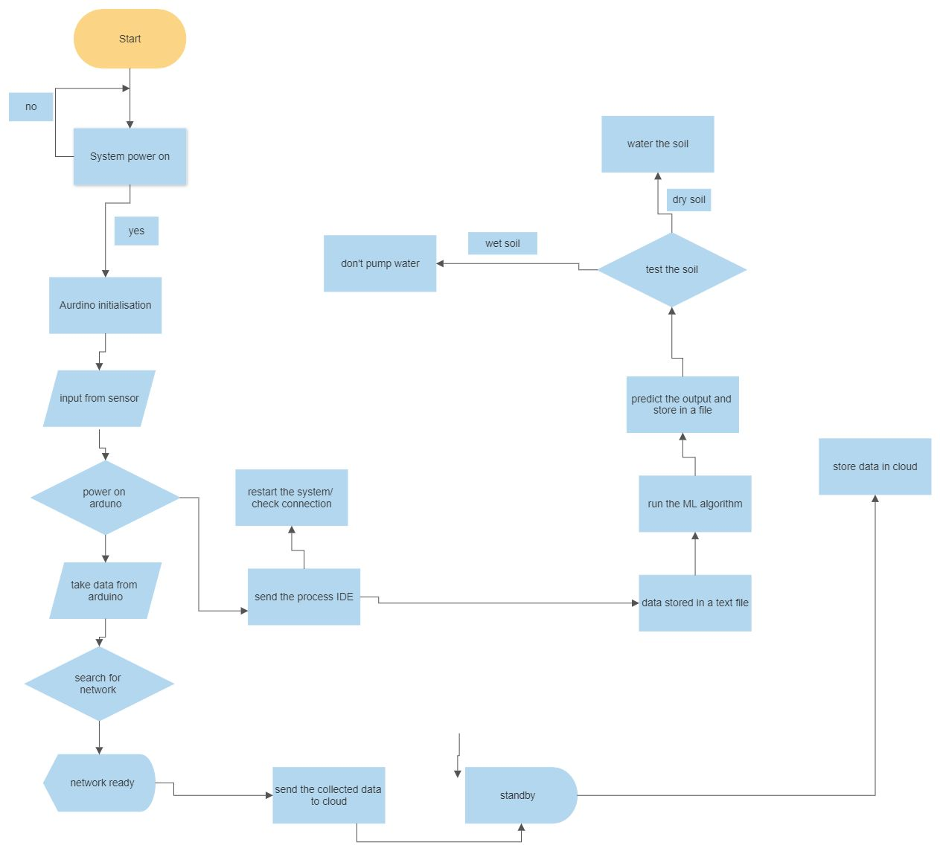

**Conclusion & Future Possibilities:**

Although it seems to be more demanding and challenging, there are many other possibilities like creating complex connections of plants of similar variety or so-called »Internet of Plants«. Also, using more than one sensor is another idea for an experimental venture, but there are also many other experimental and challenge-like ideas such as using solar power supply, timer for setting irrigation system etc. However, independently of the way used to construct it, there is no doubt that this system can be very helpful in solving many problems, from those that seem harmless to those that are on the scale of the most important and most dangerous ones for human population. By means of this system, it is possible to control the amount of water released from the process of watering the plant. Although it can be very helpful for humanity in general, agriculturists, craftsmen, and botanists are the people who could have the biggest benefi t of using this system.

**REFERENCES:**

1. C. Qingmei, Z. Zhili, and Z. Mingzhu, “The Design of Communication Nodes in the Tractor Control Network Based on ISO11783 Protocol,” in 2010 International Conference on Intelligent Computation Technology and Automation, 2010, vol. 3, pp. 772–775.

1. V. Ahmed and S. A. Ladhake, “Design of Ultra Low Cost Cell Phone Based Embedded System for Irrigation,” in 2010 International Conference on Machine Vision and Human-machine Interface, 2010, pp. 718–721.

1. Ma Yuquan, Han Shufen, and Wang Qingzhu, “New environment parameters monitoring and control system for greenhouse based on master-slave distributed,” in 2010 International Conference on Computer and Communication Technologies in Agriculture Engineering, 2010, vol. 1, pp.

31–35.

1. K. Ganesh and S. Girisha, “Embedded controller in farmers pump by solar energy (Automation of solarised water pump),” in 2011 International Conference On Recent Advancements in Electrical, Electronics And Control Engineering, 2011, pp. 226–229.

1. X. Li and Y. Yu, “A high accuracy temperature control system based on ARM9,” in 2011 International Conference on Electrical and Control Engineering, 2011, pp. 23–26.

1. E. Pradeep, R. Ganeshmurthy, K. Sekar, and E. Arun, “Automation of PV farmers pump,” in International Conference on Sustainable Energy and Intelligent Systems (SEISCON 2011), 2011, vol. 2011, no. 583 CP, pp. 163–166.

1. K. Prema, N. S. Kumar, S. S. Dash, and S. Chowdary, “Online control of remote operated agricultural robot using fuzzy controller and virtual instrumentation,” in

IEEE-International Conference On Advances In Engineering, Science And Management (ICAESM - 2012), 2012, pp.

196–201.

1. M. L. G. Polpitiya, G. R. Raban, W. K. S. S. Prasanna, D. T. S. Perera, D. P. Chandima, and U. K. D. L. Udawatta, “Wireless agricultural sensor network,” in TENCON 2012 IEEE Region 10 Conference, 2012, pp. 1–6.

1. I. Idris and Muhammad Ikhsan Sani, “Monitoring and control of aeroponic growing system for potato production,” in 2012 IEEE Conference on Control, Systems & Industrial Informatics, 2012, pp. 120–125.

1. B. Martin, V. Juliet, P. E. Sankaranarayanan, A. Gopal, and I. Rajkumar, “Wireless implementation of mems accelerometer to detect red palm weevil on palms,” in 2013 International Conference on Advanced Electronic

Systems (ICAES), 2013, pp. 248–252.

1. N. R. Patel, R. B. Lanjewar, S. S. Mathurkar, and A. A. Bhandekar, “Microcontroller based drip irrigation system using smart sensor,” in 2013 Annual IEEE India Conference (INDICON), 2013, pp. 1–5.

1. K. Sathish kannan and G.

Thilagavathi, “Online farming based on embedded systems and wireless sensor networks,” in 2013 International Conference on Computation of Power, Energy, Information and Communication (ICCPEIC), 2013, pp. 71–74.

1. M. Rosinski, “An unattended flower watering system,” Electron. Educ., vol.

1996, no. 2, pp. 26–28, 1996.

1. P. Tapak and M. Csiba, “LoT Plant Watering,” in 2018 16th International Conference on Emerging eLearning Technologies and Applications (ICETA), 2018, pp. 563–568.

1. A. Selmani et al., “Multithreading design for an embedded irrigation system running on solar power,” in 2018 4th International Conference on Optimization and Applications (ICOA), 2018, pp. 1– 5.

1. D. Divani, P. Patil, and S. K. Punjabi, “Automated plant Watering system,” in 2016 International Conference on Computation of Power, Energy Information and Commuincation

(ICCPEIC), 2016, pp. 180–182.

1. M. F. M. Azam et al., “Hybrid water pump system for hilly agricultural site,” in

2016 7th IEEE Control and System Graduate Research Colloquium (ICSGRC), 2016, no. August, pp. 109–114.

1. P. Padalalu, S. Mahajan, K. Dabir, S. Mitkar, and D. Javale, “Smart water dripping system for agriculture/farming,” in 2017 2nd International Conference for Convergence in Technology (I2CT), 2017, vol. 2017-Janua, pp. 659–662.

1. D. P, S. Sonkiya, P. Das, M. V. V., and M. V. Ramesh, “CAWIS: Context aware wireless irrigation system,” in 2014 International Conference on Computer, Communications, and Control Technology (I4CT), 2014, no. I4ct, pp. 310–315.

1. P. H. Tarange, R. G. Mevekari, and P.

A. Shinde, “Web based automatic irrigation system using wireless sensor network and embedded Linux board,” in 2015 International Conference on Circuits, Power and Computing

Technologies [ICCPCT-2015], 2015, pp. 1–

5.

1. N. S. Ishak, A. H. Awang, N. N. S. Bahri, and A. M. M. Zaimi, “GSM activated watering system prototype,” in 2015 IEEE

International RF and Microwave Conference (RFM), 2015, no. Rfm, pp.

252–256.

1. T. K. Toai and V. M. Huan, “Implementing the Markov Decision

Process for Efficient Water Utilization with Arduino Board in Agriculture,” in 2019 International Conference on System Science and Engineering (ICSSE), 2019, pp.

335–340.